EEMEM0018 Lab Activity 2 - Sensor Interfacing and Threads

- Objectives
- Required Equipment and Components
- Hardware Setup
  - LM335 Temperature Sensor Overview
  - LM335 Pinout
  - Wiring
- Project Setup
  - nRF54L15 DK Board Configuration
  - Temperature Reader Application
- Dissecting the ADC code
  - ADC Channel Configuration using Devicetree
  - ADC reading function
- Lab Tasks
  - Lab Task 1: Extracting Voltage and Temperature
  - Lab Task 2: Temperature Threshold LED Indicator (optional)
  - Lab Task 3: Polling vs Timer-Based Event-Driven Sampling
  - Lab Task 4: Interrupt/event-driven ADC Sampling (optional)
  - Exercise: Multi-Threaded Temperature Monitoring and Control
  - References:

Objectives
This laboratory exercise introduces analogue sensor data acquisition using the Analogue-to-Digital Converter (ADC) peripheral on the nRF54L15 DK, while maintaining a predefined Bluetooth Low Energy (BLE) framework. An ADC is used to transform an analogue signal, such as continuous analogue voltage, into a digital format, enabling it to be read by a processor and enabling the processor to take actions based on the read values. Upon completion of this lab, students will be able to:
- Work with a pre-configured ADC project for Zephyr
- Acquire raw ADC samples from an LM335 temperature sensor
- Convert raw ADC readings into millivolt values using the configured gain and reference settings
- Derive temperature values in degrees Celsius from the measured sensor voltage
- Observe and validate temperature changes through direct interaction with the sensor (e.g. touch)
This lab is designed to bridge basic peripheral configuration and RTOS-based design concepts introduced in later exercises.

Required Equipment and Components
- nRF54L15 DK Development Kit
- LM335 analogue temperature sensor
- 330 Ω series resistor (for 3.3 V operation)
- Breadboard and jumper wires
- USB-C cable
- PC running nRF Connect for Desktop and VS Code

Hardware Setup

LM335 Temperature Sensor Overview
The LM335 series are precision, easily calibrated, integrated circuit temperature sensors. Its output voltage changes in direct proportion to the absolute temperature measured in Kelvin, which can be described using:
$V_{out} = 10 \times T_K$, where Vout is the output voltage in mV and T(K) the temperature in Kelvin. Therefore, the temperature in Celsius, $T_c$, is given by:
$T_C = \frac{V_{out}}{10} - 273.15$
This analogue voltage can be converted to a digital value using the built-in ADC in the nRF54L15 SoC for further processing.

LM335 Pinout

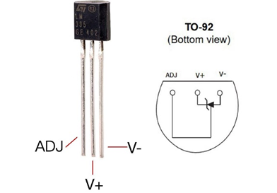
Pin | Name | Description | Usage in this Lab
1 | ADJ | Calibration Pin | Leave unconnected
2 | V+ | Temperature dependent voltage | Connect to ADC input pin of nRF54L15 and VDD
3 | V- | Ground | Connect to a GND pin nRF54L15

Wiring
Here we describe the LM335 and the nRF54L16 DK board wiring connections and it is described the table below. For better understanding, a diagram is also included to demonstrate how each connection should be made.
LM335 Pin | nRF54L15 Connection
ADJ | Leave Unconnected
Vout | Connect to ADC input pin (P1.11)  Connect to VDD (3.3V) through 330 Ohm resistor (This will set the operating current to 1mA)
GND | Connect nRF54L15 GND
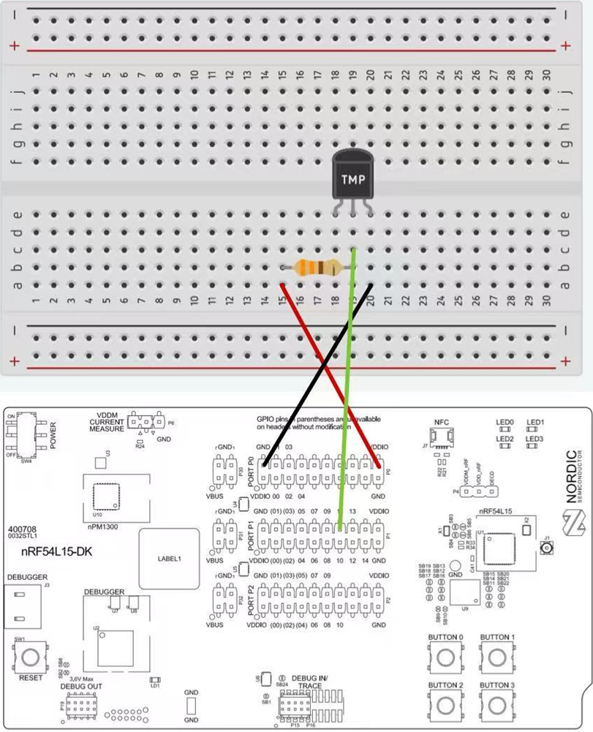

Project Setup

nRF54L15 DK Board Configuration
The nRF54L15 chip features an on-chip ADC, specifically a Successive Approximation ADC (SAADC). SAADCs are widely used in microcontrollers and embedded systems because of their efficient architecture and low power consumption. For more information, please follow:
SAADC — Successive approximation analog-to-digital converter
ADC peripheral on Nordic devices - Nordic Developer Academy
By default, the nRF54L15 ADC operates with a 1.8 V reference voltage, limiting the maximum measurable input to 1.8 V. Since the LM335 sensor can output up to approximately 3.0 V, the ADC reference should be reconfigured to 3.3 V to prevent input saturation and ensure accurate readings. Follow the steps below to configure the ADC:
- Open nRF connect for Desktop
- Go to Board Configurator (if this is not intalled you will have to do so.)
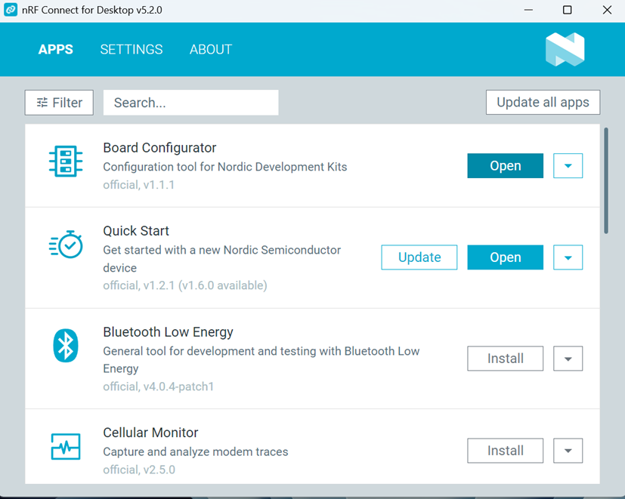
- Click on SELECT DEVICE. Your nRF54L15 DK board should be connected to the PC
- Locate VDD (nPM VOUT1) and click on 3.3V.
- Now click on Write Config which will update the board.

Temperature Reader Application
We have created an application example for your use.
- Download the project archive (week2-adc-event-template.zip) from Blackboard (Learning and Teaching Area -> Week 2 -> Lab Activity). Unzip it in your working folder.
- Launch VS code → nRF Connect for VS Code → Click Open an existing application → Select the task 1 in the extracted folder in step 1.
- Check build configuration
- Build, Flash & Open UART
- Verify that the program runs and prints some ADC output
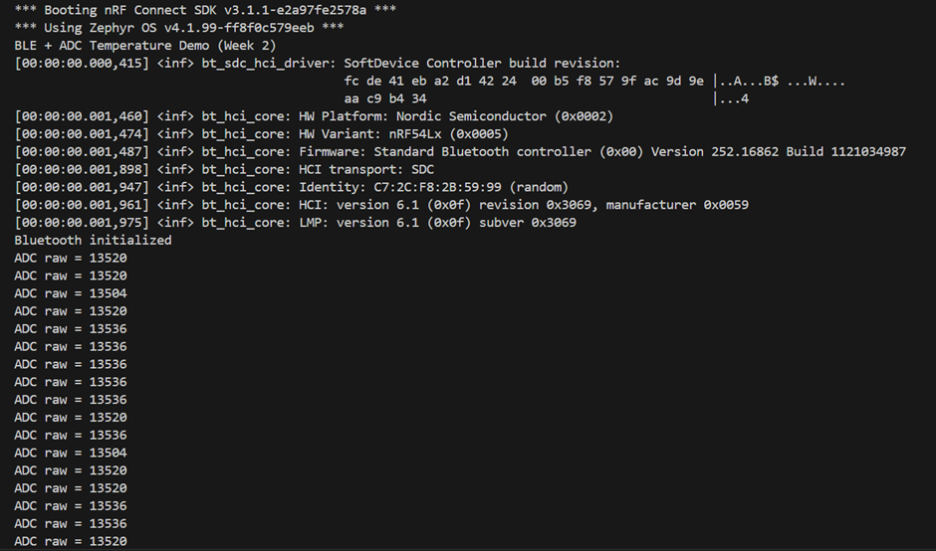

Dissecting the ADC code
The application provided here has been modified from an example provided in the SDK. If you want to know more about this code, please follow: ADC peripheral on Nordic devices - Nordic Developer Academy

ADC Channel Configuration using Devicetree
Goto Explorer in VS code. And then click on Boards and nrf54l15dk_nrf54l15_cpuapp.overlay. In this file, you will see the statement: io-channels = <&adc 0>;.
This line in the overlay file specifies which ADC is used in the application. In this case, the on-chip SAADC peripheral is selected. The value 0 indicates that channel 0 of the SAADC is being used out of its eight available channels. Note that this channel number refers to the SAADC’s internal channel index, not a GPIO port or pin number. It simply identifies which internal ADC channel is mapped for sampling, and the actual GPIO pin used for input is defined elsewhere in the configuration.
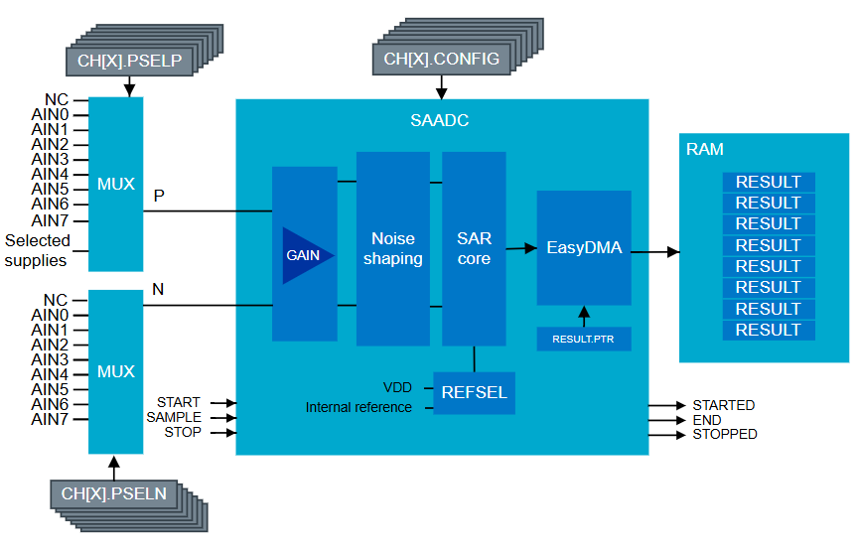
SAADC channel 0 is mapped to pin P1.11 (AIN4) on the nRF54L15 DK board. This mapping is defined in the board’s devicetree and is not exposed to the application. You do not need to manually configure GPIO pins for SAADC; Zephyr automatically sets up the correct analogue input routing. The devicetree will also configure other setups for the ADC such as the reference voltage, gain and the acquisition time.
&adc {
#address-cells = <1>;
#size-cells = <0>;
status = "okay";

channel@0 {
reg = <0>;
zephyr,gain = "ADC_GAIN_1_4";
zephyr,reference = "ADC_REF_INTERNAL";
zephyr,acquisition-time = <ADC_ACQ_TIME_DEFAULT>;
zephyr,input-positive = <NRF_SAADC_AIN4>; /* AIN4 / P1.11 */
zephyr,resolution = <14>;
};
};
In the application, we use ADC_DT_SPEC_GET(DT_PATH(zephyr_user to retrieve all configuration details from the devicetree for this ADC channel. Students do not need to modify this line for this task.
We also need to create a variable to store one ADC value. It will hold the raw ADC value (signed 16-bit integer) after adc_read() finishes. That is expressed using: static int16_t adc_buf;

ADC reading function
To read the ADC value, we have developed a function:
static int read_and_print_temperature(void)
This function is called periodically inside the `while (1)` loop in `main()`:
while (1) {
/* Week-2 goal: Only read ADC + print temperature */
read_and_print_temperature();
/* Week-3 will update BLE advertising temperature here */
k_sleep(K_MSEC(SAMPLE_PERIOD_MS));
}
Zephyr API provides functions to setup the ADC and to read the channels (For more information: Zephyr API Documentation: ADC. The following are some useful ADC related functions available.
- adc_is_ready_dt(&adc_channel) – check whether the ADC device is ready.
- dc_channel_setup_dt(&adc_channel) – configure the channel according to devicetree.
- adc_sequence_init_dt(&adc_channel, &sequence) – initialize an ADC sequence structure.
- dadc_read(adc_channel.dev, &sequence) – perform a conversion and fill `adc_buf`.
- adc_raw_to_millivolts_dt(&adc_channel, &mv) – convert raw ADC to millivolts.
Inside the read_and_print_temperature() function, we will carry out the following steps using the above API functions:
- Check ADC readiness
if (!adc_is_ready_dt(&adc_channel)) {
printk("ADC %s is not ready\n", adc_channel.dev->name);
return -EIO;
}
- Configure the ADC channel: Loads gain, reference voltage, and other parameters from devicetree and prepares the selected channel.
err = adc_channel_setup_dt(&adc_channel);
- Prepare an ADC sequence: Defines where the conversion result will be stored (`adc_buf`) and how many samples.
struct adc_sequence sequence = {
.buffer = &adc_buf,
.buffer_size = sizeof(adc_buf),
};
err = adc_sequence_init_dt(&adc_channel, &sequence);
- Perform one ADC conversion: After this call, `raw` contains the raw ADC result.
err = adc_read(adc_channel.dev, &sequence);
int16_t raw = adc_buf;
<you code goes here>

Lab Tasks

Lab Task 1: Extracting Voltage and Temperature
In this task, you are required to complete code to convert the raw ADC values to temperature inside the read_and_print_temperature() function.
int16_t raw = adc_buf;

printk("ADC raw = %d\n", raw);

/* ====== convert raw → millivolts and print ====== */
/* TODO: students add mv conversion here */

/* ====== convert mv → temperature (°C) and print ====== */
/* TODO: students add temperature conversion here */
Expected student outcome:
- Understand how adc_raw_to_millivolts_dt() uses gain & reference settings
- Convert LM335 voltage to temperature correctly
- Observe reasonable room temperature readings (around 20–26°C)
Example UART output:
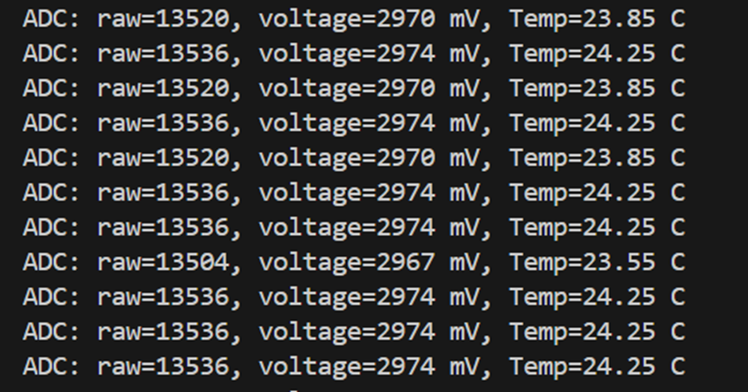

Lab Task 2: Temperature Threshold LED Indicator (optional)
In this task, the measured temperature obtained in Task 1 is further utilised to implement a simple local control function. A temperature threshold of 28C is defined, above which an on-board LED is switched on to indicate an over-temperature condition. When the temperature is below or equal to the threshold, the LED remains off.
Hardware and GPIO Setup: The on-board LED is accessed via the led0 alias defined in the board devicetree. During system initialisation, the corresponding GPIO pin is configured as an output, allowing the LED to be controlled directly from software without any additional hardware modifications.
Software Modifications: After the ADC reading is converted into a temperature value in degrees Celsius, the result is compared against the predefined threshold. Based on this comparison, the LED state is updated using a GPIO output write. This decision logic is executed within the same periodic loop as the temperature measurement, ensuring that the LED state always reflects the most recent sensor reading. The key code additions for this task are shown below:
int led_err;
bool led_on = (temp_c > TEMP_THRESHOLD_C);
led_err = gpio_pin_set_dt(&led0, led_on ? 1 : 0);
Experimental Observation: During testing, the LED remained off under normal room temperature conditions. When the temperature sensor was warmed by touch, the measured temperature exceeded 30 °C, causing the LED to switch on. This behaviour was repeatable and consistent with the expected threshold logic. The UART output further confirmed correct operation by printing both the temperature value and the corresponding LED state.
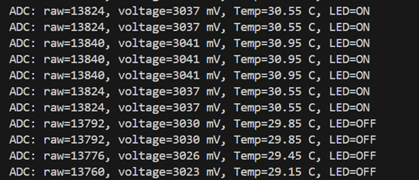

Lab Task 3: Polling vs Timer-Based Event-Driven Sampling
In this task, you are not required to implement new ADC functionality. Instead, they reuse the existing sampling and processing function and focus on how the sampling is triggered. The task demonstrates that the key difference between polling and event-driven designs lies in the control flow and execution context, rather than the sensor processing logic itself.
Polling-Based Sampling: In the baseline implementation, ADC sampling is performed using a polling-based approach. The main thread executes an infinite loop, periodically invoking the ADC sampling function followed by a fixed delay using k_sleep() as shown below:
while (1) {
read_and_print_temperature(NULL);
k_sleep(K_MSEC(SAMPLE_PERIOD_MS));
}
In this design, the main application thread is responsible for explicitly controlling the sampling timing. The CPU wakes up at a fixed interval, performs the ADC conversion, processes the temperature value, updates the LED state, and then returns to sleep. While this approach is simple and intuitive, it has several limitations:
- Application logic becomes tightly coupled to the main loop
- Adding multiple periodic tasks quickly leads to a large and less maintainable super-loop
- The structure does not fully exploit the scheduling and event-handling mechanisms provided by an RTOS
Nevertheless, polling provides a clear and accessible starting point for students to understand periodic sensor sampling.
Improved Design: Timer-Based Event-Driven Sampling: To demonstrate a more RTOS-oriented design, the polling mechanism is replaced with a timer-based event-driven approach using a Zephyr kernel timer (k_timer()).
In this implementation, a periodic timer is configured to expire at a fixed interval. Upon expiration, the timer handler does not perform ADC sampling directly. Instead, it submits a work item to the system workqueue, ensuring that the ADC driver is accessed from a valid thread context. For the API calls, please refer to https://docs.zephyrproject.org/latest/kernel/services/timing/timers.html:
static void sample_timer_handler(struct k_timer *timer)
{
k_work_submit(&sample_work);
}
The actual ADC sampling and temperature processing are executed inside the work handler:
static void sample_work_handler(struct k_work *work)
{
read_and_print_temperature(NULL);
}
nce the timer is started, the main application thread no longer participates in periodic sampling and can remain idle indefinitely:
while (1) {
k_sleep(K_FOREVER);
}
This structure decouples sampling timing from the main application flow and aligns more closely with RTOS design principles. Periodic tasks are triggered by events rather than being manually managed inside a continuous loop.
- The key difference between the two approaches lies in how sampling is triggered:
- In the polling approach, the main thread actively controls when sampling occurs.
In the event-driven approach, sampling is triggered by a kernel event (timer expiry), and the main thread becomes passive.
The timer-based design offers several advantages:
- Improved modularity and readability
- Easier extension to multiple periodic tasks
- Clear separation between event sources and processing logic
- Better representation of real-world RTOS-based embedded systems
Importantly, this event-driven implementation does not rely on ADC hardware interrupts. Instead, it uses RTOS timers as the event source, keeping the design conceptually simple while still illustrating the benefits of event-driven execution.

Lab Task 4: Interrupt/event-driven ADC Sampling (optional)
In this task, ADC sampling is performed using Zephyr’s asynchronous ADC API (adc_read_async). Instead of blocking until the conversion finishes, the ADC driver triggers a hardware interrupt on completion and signals a kernel event (k_poll_signal). The application thread waits for this event using k_poll() and only processes the ADC result once the conversion has completed.
All ADC API calls remain in thread context, while interrupt handling is managed internally by the driver. This approach demonstrates how hardware-interrupt-driven events differ from RTOS timer–based scheduling, and how event-driven peripherals enable more responsive and energy-efficient designs.

Exercise: Multi-Threaded Temperature Monitoring and Control
(Note: This task serves as the foundation for a portion of the formal coursework. Detailed specifications will be released in the coursework documentation in mid-February.)
In this task, you are required to design and implement a multi-threaded application using the Zephyr RTOS. The application shall be structured using three distinct threads, each with a clearly defined responsibility:
- ADC Sampling Thread: This thread shall periodically acquire temperature data from the ADC-connected sensor.
- Data Processing Thread: This thread shall process the sampled temperature data and compute the average temperature over a one-minute window. If the computed average temperature exceeds 28 °C, the thread shall activate LED0.
- Reporting Thread: This thread shall be responsible for outputting the current temperature readings and the LED status to the serial terminal.
The implementation must demonstrate correct use of thread creation, inter-thread communication, and synchronization mechanisms, ensuring reliable data flow and deterministic behaviour across all threads

References:
nRF Connect SDK Fundamentals - Nordic Developer Academy
nRF Connect SDK Intermediate - Nordic Developer Academy
SAADC — Successive approximation analog-to-digital converter

